Southern River College

**2021**

**YEAR 12 PHYSICS**

**TOPIC TEST 3**

**ELECTROMAGNETISM**

**NAME**: __________________________

**TEACHER**:_______________________

**MARKS**: **/40**

* **Answer all questions**
* **Show all working.**
* **Give your final answer to three significant figures where appropriate.**

1. A copper wire carries a current of 5.50 Amps in a direction out of the page.
2. Draw a diagram showing the shape of the magnetic field around the wire. (2 marks)

⊙

1. Calculate the magnetic field strength at a distance of 5.50 cm from the wire. (2 marks)
2. A DC electric motor armature with 500 turns of wire has a length of 100mm and a width of 100mm. If it has an applied current of 2.00A and a magnetic field of 0.200T, calculate the magnitude of the maximum torque supplied by the motor. (4 marks)

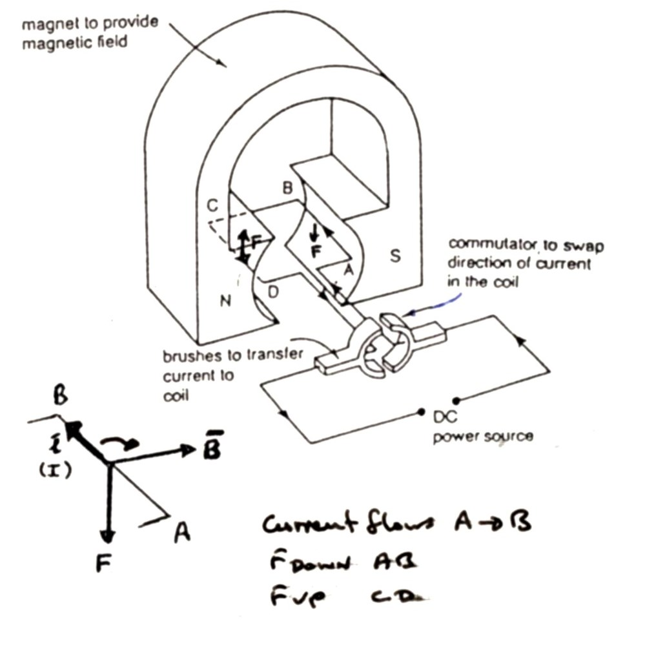

1. A small charged sphere with a mass of 81.0 milligrams is placed in an electric field as shown in the diagram below. The charged sphere is held by a thread of negligible mass.

The charge on the sphere is -3.50 x 10-7 C and the electric field strength between the charged plates is1.00 x 102 NC-1

1. Draw lines between the plates showing the electric field (2 marks)
2. Calculate the angle that the thread makes with the vertical. (3 marks)
3. c The Harry Potter Hogwarts Express train left London from Platform 9 ¾ in a Northerly direction on 1st September 1827. The train has a 1800mm wide axle and travels at an average velocity of 12.2 kmhr-1.

1. The magnetic field in London is in a direction into the ground at an angle of 71.5° below horizontal. Use the data from the table above to calculate the vertical component of the Earth’s magnetic field in London during the middle of 1827. Give your answer in the units Tesla (1 mark)

­­­­­­­­­­ ____________________________ T

1. Using this data, calculate the EMF produced between the ends of the axle.

(3 marks)

1. Which wheel will have an excess of positive charge, left or right?

(circle the correct answer) (1 mark)

1. If the train turned toward the west, what effect would this have on the EMF produced? (1 mark)

___________________________________________________________________________

1. If the train were to travel at high speed, the axle could produce a useful voltage. Using your knowledge of physics, explain in detail why this is not a practical method of providing electricity. (4 marks)

____________________________________________________________________

____________________________________________________________________

____________________________________________________________________

____________________________________________________________________

____________________________________________________________________

1. c The Harry Potter Hogwarts Express train left London from Platform 9 ¾ in a Northerly direction on 1st September 1827. The train has a 1800mm wide axle and travels at an average velocity of 12.2 kmhr-1.

1. The magnetic field in London is in a direction into the ground at an angle of 71.5° below horizontal. Use the data from the table above to calculate the vertical component of the Earth’s magnetic field in London during the middle of 1827. Give your answer in the units Tesla (1 mark)

­­­­­­­­­­ ____________________________ T

1. Using this data, calculate the EMF produced between the ends of the axle.

(3 marks)

1. Which wheel will have an excess of positive charge, left or right?

(circle the correct answer) (1 mark)

1. If the train turned toward the west, what effect would this have on the EMF produced? (1 mark)

___________________________________________________________________________

1. If the train were to travel at high speed, the axle could produce a useful voltage. Using your knowledge of physics, explain in detail why this is not a practical method of providing electricity. (4 marks)

____________________________________________________________________

____________________________________________________________________

____________________________________________________________________

____________________________________________________________________

____________________________________________________________________

1. A simple DC motor is shown in the diagram below
2. On the diagram below, label the components X, Y and Z. Briefly explain the purpose of these components on an electric motor. (6 marks)

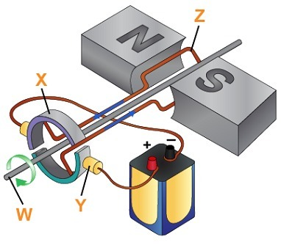

**X** _____________

______________________________________________________________________________

______________________________________________________________________________

**Y** ______________

**Z** ______________

______________________________________________________________________________

______________________________________________________________________________

1. Complete the diagram of the two wires going into the motor and draw in the power supply with the correct polarity to spin the motor in the direction shown at **W** (1 marks)
2. On the following axes, draw a graph of the torque generated by this device, starting when the coil is horizontal. Mark a scale on each of the axes. (3 marks)

+ + + + + + +

e-

* - - - - - -

An electron is placed between two parallel charged plates. The plates are separated by a distance of 1.00 mm.

1. Sketch the path of the electron on the diagram above (1 mark)
2. Given that the potential difference between the plates is 15 kV, calculate the electric field strength between the charged plates. (2 marks)
3. Calculate the energy required for the electron to move between the two plates. (2 marks)

1. Old aeroplanes used to have two parallel wires running through the front of the wings. The pilot could switch on a power supply through these wires, this resulted in a sudden repulsion between the wires which would prevent the formation of ice on the wings by cracking the ice.

The following diagram shows a cross section of the aeroplane wing including two small circles representing a cross section of the wires.

1. Show the direction of the current through the two wires. Use a dot to represent current coming out of the page and/or a cross to represent current going into the page.

(1 mark)

1. Show the direction of the magnetic field associated with each wire using a single circle for each wire.

(1 mark)

1. Explain how the repulsion is caused. (3 marks)
2. A long wire suspended horizontally in a direction perpendicular to North has a mass of 220g/m. Calculate the magnitude and direction of the theoretical current required to make the wire levitate (float) in the Earth’s magnetic field where Bhorizontal = 4.50 x 10-5 T.

NORTH (4 marks)

wire

1. (3 marks)

The diagram below shows a solenoid with magnetic compasses positioned around it. The switch in the circuit is turned off and each compass is pointing North due to the Earth’s field.

Compass

a) The circuit switch is now closed. Draw the direction of the current through the solenoid. (1 mark)

END OF TEST

b) For each magnetic compass, draw the new position of the compass needle in the empty circle alongside the compass when the switch is closed. Assume the arrowhead represents north.

(2 marks)